SOFT8026 - Data-driven Microservices
Assignment 1 Form

Instructions
Please complete the following form and include in the zip file you submit. Include screenshots / images in the appendices below the form.

Brief discussion of your architecture – why the microservices you chose, what messages are you passing between them? | There are 4 microservies.  - `tweet server` streams tweets  - `analysis client` requests tweets from the tweet server and analyses them. After analysing, it writes the results to redis  - redis stores all of the tweets, along with analysis data  - `website` displays all of the tweets and the analised data  All of the messages are streamed. The `analysis client` sends a mesasge to the `tweet server`, with a specified number of tweets it wants to recieve in the stream. A stream is then opened, and the tweets are streamed in random amounts, mostly at 2 per second, but it can be anywhere between 1 and 3. The messages in the stream are broken up into the tweet id, text, user who posted etc.  Each of those tweets are then analised, metrics are calculated and stored in redis.  Finally, the webiste retrieved the data from redis, and displays tweets and the analysis. The page automatically refreshes every 1 or 2 seconds, as to have the information upto date.  Chosing to do the microservices in the aformentioned approach gives a similar enviroment to how it would be done in practice. The tweet server mimics a twitter server in the sense that all it does is that it provides tweets. The analysis client can then analise them, and collect data that we desire. Redis is used for data storage, which benefits from it’s fast read and write speeds due to being stored in memory, perfect for lots of constant data coming in. The website then displays metrics to the user in a friendly manner, easily accessible through a browser.  This setup has the potential of easily scaling up, for example having multiple instances of the analysis client.
Briefly discuss how far you got with the following functional requirements:
1. Reading and streaming of  the tweet data | The analyis client requets a number of tweets from the server. The server then starts steaming them back. Once the streaming is complete, the analyis client sends another request for more tweets to be streamed.  There is a variation in number of tweets streamed, with 2 tweets per second being most common.
2. Data analysis; what analytics / metrics did you calculate? | Each tweet displays the amount of words in it.  There is an aggregate metric of total words and vowels in all of the tweets, and I keep track of the average vowels per word, which can be surprisingly high as majority of the tweets are informal and some words are elongated on particular letters or sounds, for example “I am sooooo angry!”  There is a 3 minute sentiment of the tweets that are streamed in. Every time a tweet comes in, the sentiment is updated. Any tweets that came in more than 3 minutes ago are not included in the sentiment. This keeps the analysis upto date at all times.  For the `Most of` metric, we keep track of a tweet with the most words, and how many words were in that tweet.
3. Web page with list or summary of analytics / metrics | The website displays the analytics on the left side of the screen.  There is a list of tweets on the right side of the screen which is updated every 1 to 2 seconds. The tweets are in a chonological order, with the most recently analysed tweet on top. The tweets are color coded based on their sentiment.
Checklist:
I used gRPC | Y
I used streaming with gRPC | Y
I built docker images using Dockerfiles | Y
I orchestrated my application using Docker Compose and a YAML file | Y
Any other comments? | When running the project, please extract the `sentiment140.zip` and palce the `training.1600000.processed.noemoticon.csv` file into the root folder of the project, next to the `README.md` file.

Appendix A – Your Architecture Sketch / Diagram
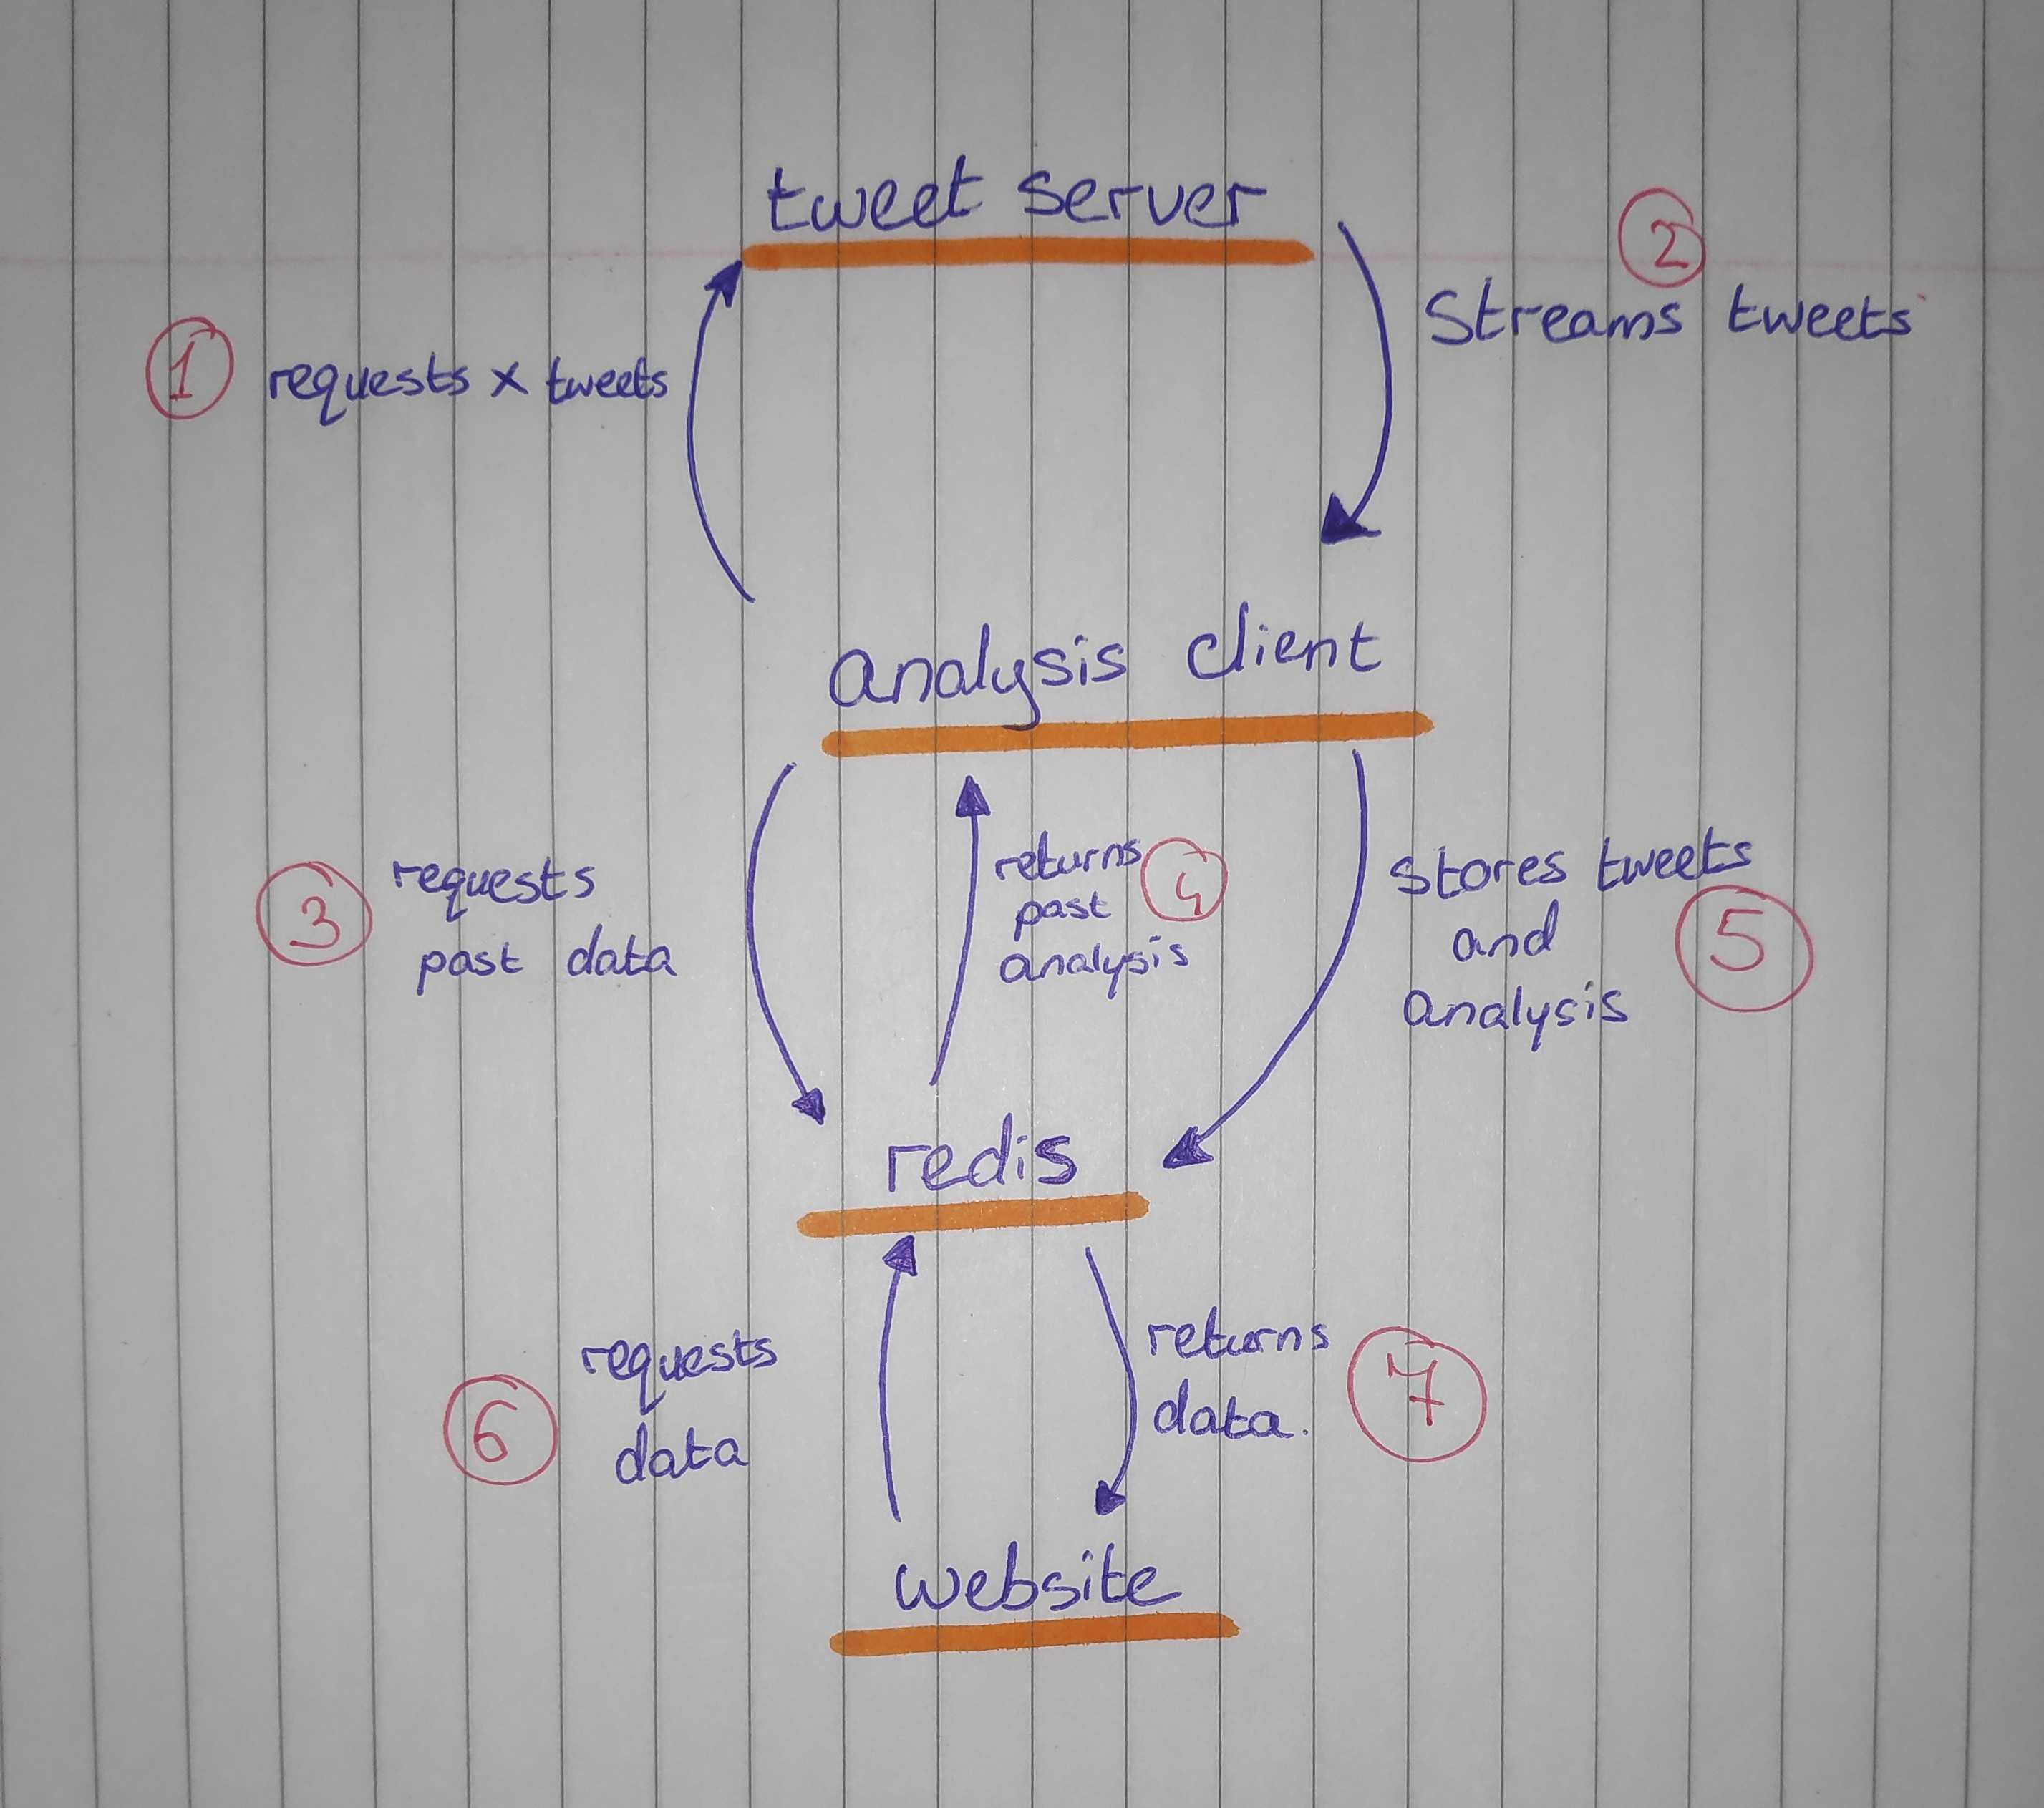

Appendix B – Output from a sample run
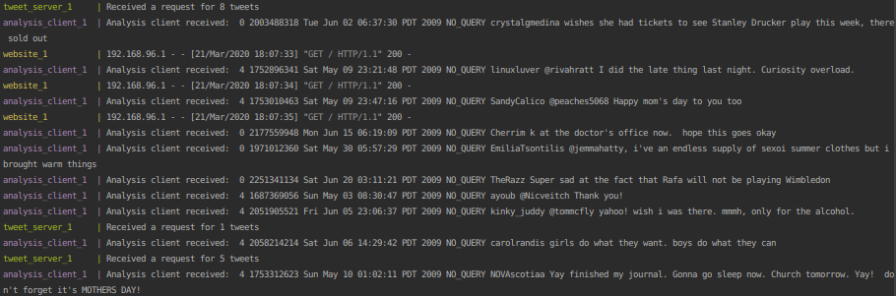

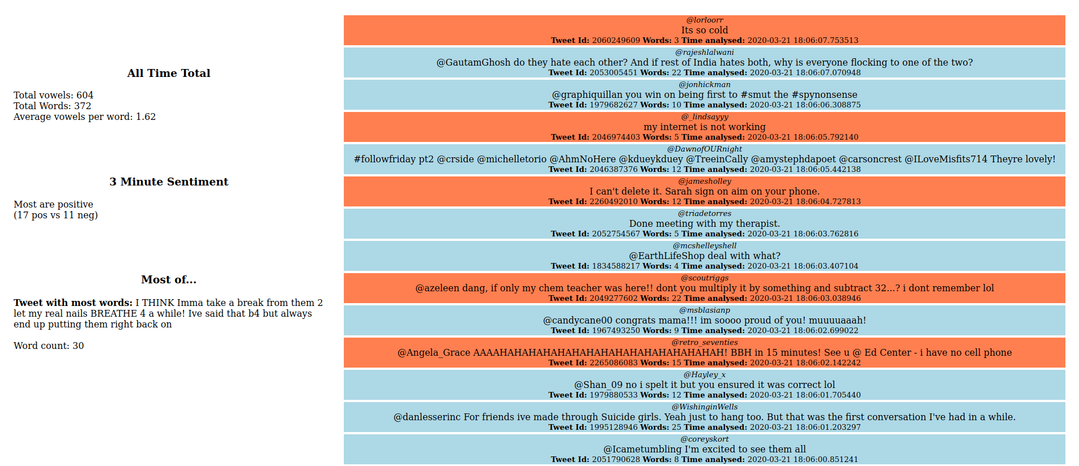
Appendix C – Screenshot from web page

